
Sukkur IBA University
Department of Computer Science
ESE-201: Digital Logic Design Lab

Lab # 03: X-OR & X-NOR Gates
Instructor: Muhammad Ismail Qureshi
Submission Profile
Name: Ghulam Mustafa Submission date 25/12/2025
CMS ID: 023-24-0513 Marks obtained:
Comments: Receiving authority name and signature:

________________________________________________________________________________
Instructor Signature

Note: Submit this lab hand-out on LMS/e-learning before the next lab with attached solved activities and exercises.
Lab Learning Objectives:
Upon successful completion of this experiment, the student will be able:
- To implement and verify X-OR gate operations using 74LS86 IC & NI ELVIS Kit
- To implement and verify X-NOR gate operations using 74LS266 IC & NI ELVIS Kit

Lab Hardware and Software Required:
- 74LS86 IC (X-OR gate )
- 74LS266 IC(X-NOR gate)
- NI ELVIS Kit
- Breadboard
- Connecting Wires

Background Theory:

X-OR gate:

Exclusive OR gate, commonly abbreviated as X-OR is a special type of OR gate. Logic symbol for the XOR gate is shown in Fig 3.1 (a & b). The output of an X-OR is high only when the two inputs are at opposite logic levels. Alternatively, X-OR gate provides a high output if one input or the other is high, but not both. The X-OR gate has only two inputs. Unlike the other gates, it never has more than two inputs. The X-OR output expression is written as X=A⊕B, where the symbol “⊕” represented X-OR operation.
A
B
$$X=A⊕B$$
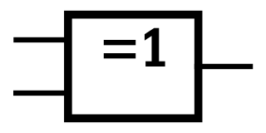
A
B
$$X=A⊕B$$

Fig 3.1: (a) Distinctive symbol of X-OR gate (b) Standard X-OR gate symbol
74LS86 2-Input X-OR gate IC:
In order to implement the X-OR operation using IC, the TTL 74LS86 2-input X-OR gate IC can be used. This IC has 14 pin Dual Inline Package (DIP) configuration as shown in fig 3.2. The power supply connections are made to pin 7 and 14. Pin 1 is identified by a small indented circle next to it or by a notch cut out between pin 1 and 14.
Fig 3.2: 74LS86 2-input X-OR gate IC pin configuration
X-NOR gate
Exclusive NOR (abbreviated as X-NOR) is the complement of X-OR, like the X-OR gate, the X-NOR gate has only two inputs. The logic symbol for X-NOR gate is shown in Fig 3.3 (a & b).
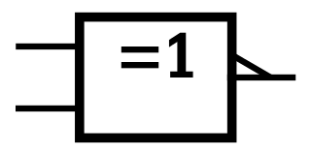

The characteristics of X-NOR will be completely opposite of X-OR gate. As in X-OR gate, the same inputs caused low output but here in X-NOR the case is reversed, means on same inputs the output is high.
A
B
$$X=\overline{A⊕B}$$
B
$$X=\overline{A⊕B}$$
A

Fig 3.3: (a) Distinctive symbol of 2-input X-NOR gate (b) Standard 2-input X-NOR gate symbol
74LS266 2-input X-NOR gate IC:
In order to implement the NOR gate operation using IC, the TTL 74LS266 2-input X-NOR gate IC can be used. This IC has 14 pin Dual Inline Package (DIP) configuration as shown in Fig 3.4. The power supply connections are made to pin 7 and 14. Pin 1 is identified by a small indented circle next to it or by a notch cut out between pin 1 and 14.
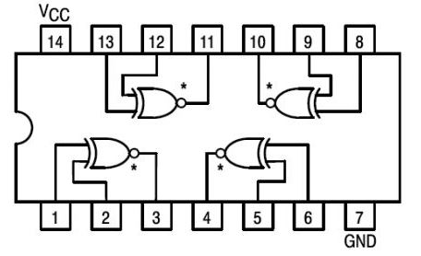
Fig 3.4: 74LS266 2-input X-NOR gate IC pin configuration
Lab Examples:
Implementation of X-OR gate
- In order to implement the X-OR gate operations with the help of ICs, take the 74LS86
- Pin Assignments for the ICs have been shown in Fig 3.2
- Take 74LS86 IC and insert it in the breadboard present on the NI ELVIS kit
- Connect its pin 14 to +5V and pin 7 to ground
- Use first gate (any one can be taken) from IC by connecting input pin 1 & input pin 2 to SW0 & SW1 respectively, and output pin3to LED and observe the AND gate operation
- Fill the following observation table
Table 3.1: Observation table of 2-input X-OR gate
Input |  | Output
A | B | LED (on / off) | Level ( 1 / 0 )
0 | 0 | Off | 0
0 | 1 | On | 1
1 | 0 | On | 1
1 | 1 | Off | 0
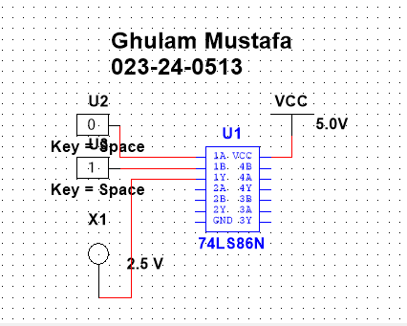
Lab Activities:
Implementation of X-NOR gate
- In order to implement the X-NOR operations with the help of IC, take the 74LS266 IC
- Pin Assignments for the ICs have been shown in Fig 3.4
- Take 74LS266 IC and insert it in the breadboard present on the NI ELVIS kit
- Connect its pin 14 to +5V and pin 7 to ground
- Use first gate (any one can be taken) from IC by connecting input pin 1 & input pin 2 to SW0 & SW1 respectively, and output pin3to LED and observe the AND gate operation
- Fill the following observation table
Table 3.2: Observation Table of 2-input X-NOR gate
Input |  | Output
A | B | LED (on / off) | Level ( 1 / 0 )
0 | 0 | On | 1
0 | 1 | Off | 0
1 | 0 | Off | 0
1 | 1 | On | 1

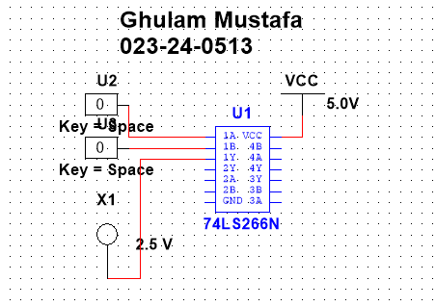
Lab Exercises:
XOR and XNOR Gate Applications
XOR and XNOR gates are used to detect dissimilar and similar inputs. This property of XOR and XNOR gates is used to detect odd and even number of 1s in a Parity Detection circuit.
- Odd number of 1’s detector
Consider the three XOR gate logic circuit which is used to detect odd number of 1's in
a 4-bit binary input combination.
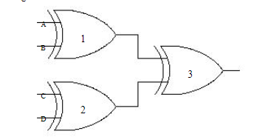
A
D
C
B
Figure 3.5: XOR gate based odd number of 1s detector

Implement Odd number of 1’s detector
Describe the operation of circuit
Fill the observation table

- Even number of 1s detector
The logic circuit based on two XOR and a single XNOR gate which is used to detect even number of 1’s in a 4-bit binary input combination.
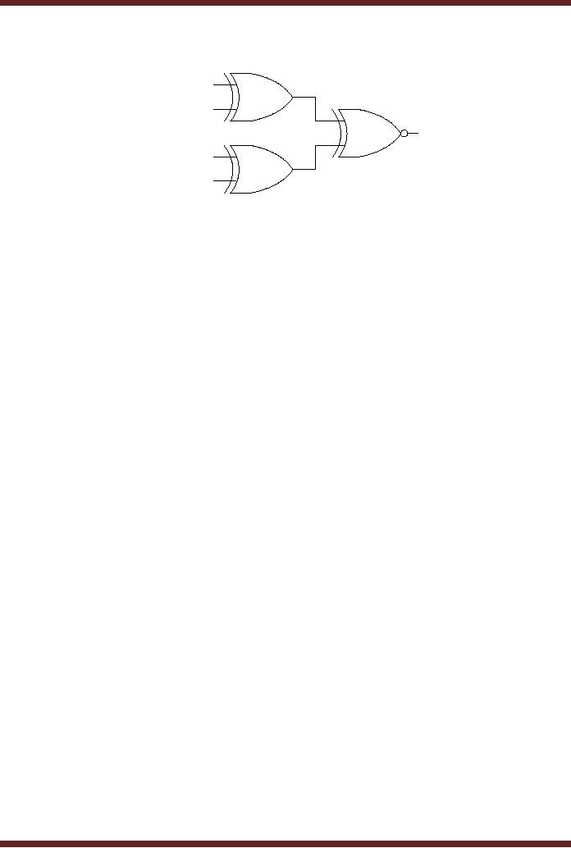
D
C
B
A
Figure 3.6: XOR & XNOR gate based even number of 1s detector
Implement Even number of 1s detector
Describe the operation of circuit
Fill the observation table

Odd number of 1s detector
Description of Circuit:
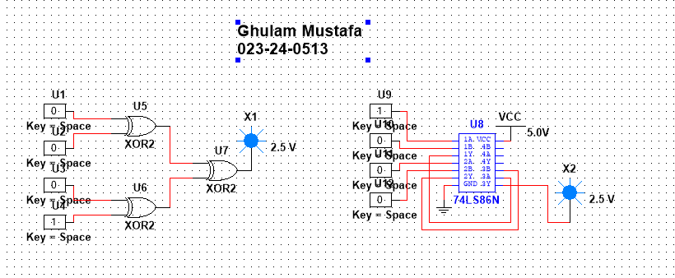

Table 3.3: Observation Table for Odd number of 1s detector
Input |  |  |  | Output
A | B | C | D | LED (on / off) | Level ( 1 / 0 )
0 | 0 | 0 | 0 | Off | 0
0 | 0 | 0 | 1 | On | 1
0 | 0 | 1 | 0 | On | 1
0 | 0 | 1 | 1 | Off | 0
0 | 1 | 0 | 0 | On | 1
0 | 1 | 0 | 1 | Off | 0
0 | 1 | 1 | 0 | Off | 0
0 | 1 | 1 | 1 | On | 1
1 | 0 | 0 | 0 | On | 1
1 | 0 | 0 | 1 | Off | 0
1 | 0 | 1 | 0 | Off | 0
1 | 0 | 1 | 1 | On | 1
1 | 1 | 0 | 0 | Off | 0
1 | 1 | 0 | 1 | On | 1
1 | 1 | 1 | 0 | On | 1
1 | 1 | 1 | 1 | Off | 0

Even number of 1s detector
Description of Circuit
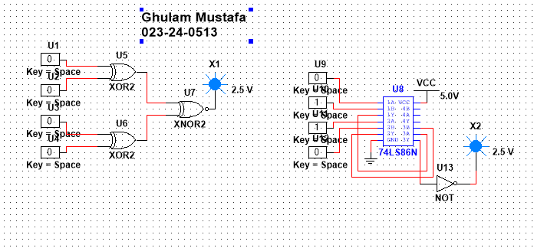

Table 3.4: Observation Table of Even number of 1s detector
Input |  |  |  | Output
A | B | C | D | LED (on / off) | Level ( 1 / 0 )
0 | 0 | 0 | 0 | on | 1
0 | 0 | 0 | 1 | Off | 0
0 | 0 | 1 | 0 | Off | 0
0 | 0 | 1 | 1 | on | 1
0 | 1 | 0 | 0 | Off | 0
0 | 1 | 0 | 1 | on | 1
0 | 1 | 1 | 0 | on | 1
0 | 1 | 1 | 1 | Off | 0
1 | 0 | 0 | 0 | Off | 0
1 | 0 | 0 | 1 | on | 1
1 | 0 | 1 | 0 | on | 1
1 | 0 | 1 | 1 | Off | 0
1 | 1 | 0 | 0 | on | 1
1 | 1 | 0 | 1 | Off | 0
1 | 1 | 1 | 0 | Off | 0
1 | 1 | 1 | 1 | on | 1

Even number of 1s detector and odd number of 1s detector
- A certain system contains two identical circuits operating in parallel. As long as both operating properly, the outputs of both circuits are always the same. If one of the circuits fails, the outputs will be at opposite levels at some time. Devise a way to detect that a failure has occurred in one of the circuits.
Solution:
The device you need is an Exclusive-OR (XOR) gate.
The XOR gate (short for "Exclusive OR") is a digital logic gate that implements the following behavior, which matches your requirements perfectly:
- Inputs: It takes the outputs of your two parallel circuits (A and B).
- Logic: It outputs a 1 (High) if and only if the inputs are not equal (one is 1, the other is 0).
- Result:
  - If A=B (Both circuits working), Output = 0 (Safe).
  - If A / B (One circuit failed), Output = 1 (Alarm).
Circuit Diagram:
